**Chapter 3:**

**SYSTEM DESIGN**

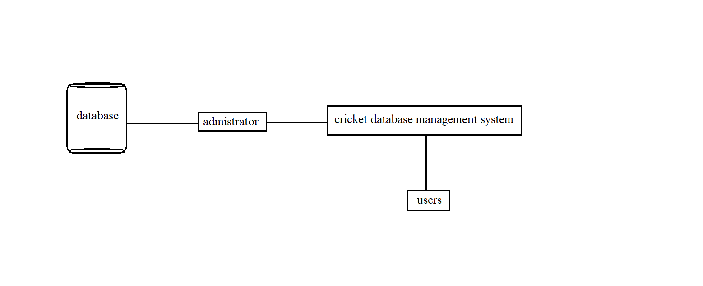**3.1 System Architecture**

**Architecture**

**3.1.1 Administration module:**

This module is protected by the username and password .Ordinary users will not be permitted to enter this area of the software. It mainly maintains the master data. The administrator can modify the data that has been already entered and also can insert/add new data into the database and can also update and delete the database.

**3.1.2 User module:**

User has a username and password like administrator but if he is a new user then he can register and access the database. User can get the details of all the coaches, players, matches, scoreboard of the matches, etc. He can't modify the database but just view the details.

**3.1.3 Cricket module:**

It has the data of all the players, matches played by the team. It also has the scoreboard of all the matches where we can get information about the scores of each player in the match and the wickets taken by the player.

**3.1.4 Database:**

Data are known facts that can be recorded and that have implicit meaning. A database is a collection of related data. Database management system is a collection of programs that enables users to create and maintain the database. It is a general-purpose software system that facilitates the processes of defining, constructing, manipulating, and sharing database among various users and applications.

**3.2: ER-DIAGRAM**

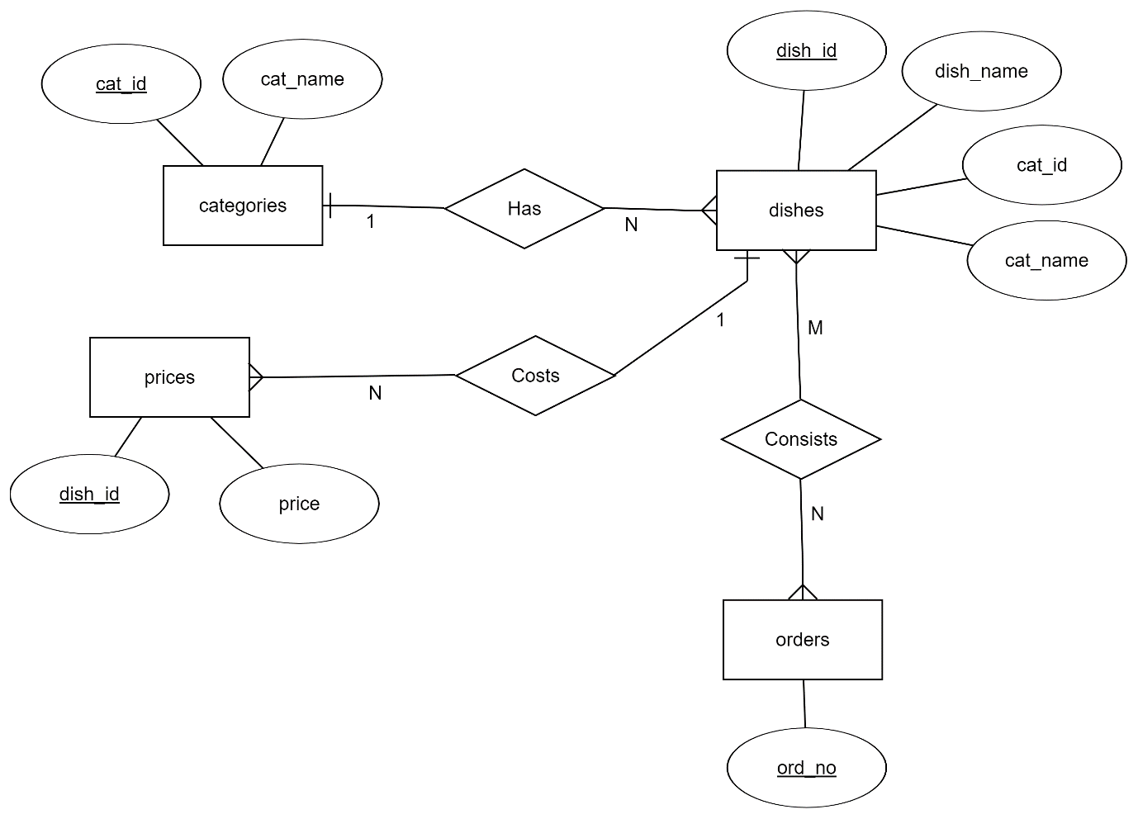

**3.3 Schema Diagram**